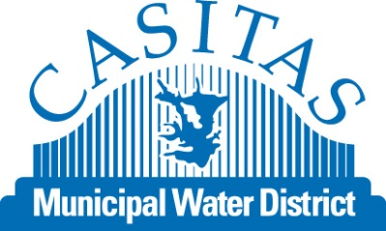**BUSINESS & OTHER**

**WATER RESTRICTIONS NOW IN EFFECT**

|  |  |  |  |
| --- | --- | --- | --- |
| Mandatory Water Restrictions to Include the following: | | | |
|  | * Limit of two days per week outdoor irrigation * Limit irrigation hours to 10 am to 6 pm | C:\Users\rmerckling\AppData\Local\Microsoft\Windows\Temporary Internet Files\Content.IE5\55SCF88M\MP900448554[1].jpg | Sweep, don’t wash sidewalks, driveways, and parking areas except for safety and sanitary purposes |
| C:\Users\RMERCK~1\AppData\Local\Temp\MP900386102.JPG | Keep irrigation on the landscape  Not on sidewalks or streets | C:\Users\rmerckling\AppData\Local\Microsoft\Windows\Temporary Internet Files\Content.IE5\2536LQ60\MC900252185[1].wmf | Hose nozzle shut-offs are required at all times when   * Cleaning vehicles * Hand watering landscape areas |
| * + - * Eating and drinking establishments provide drinking water served upon request only       * Food preparation establishments prohibition against non-water conserving dish wash sprays | | * + - * Provide option to not launder linen and towels daily at hotels, motels, and other lodging establishments       * Fountains and decorative water features must be recirculated | |
| **Please adjust irrigation timer and sprinkler heads to meet the mandatory outdoor restrictions** | | | |
|  | | | |
| **Large Landscaped areas greater than 3 acres may request a variance for the two day watering restriction conditioned upon a 20% overall reduction in usage from 2013 monthly usage. Contact Casitas to inquire about a conditional variance. (Large landscapes include areas such as golf courses, parks, schools, and cemeteries.** | | | |
| **Violations and Penalties** | | | |
| Notices of water waste violations will be by telephone, mail, hand-delivery, or posting at premises. A written notice will be issued stating time, place and general description of violation or repeat of violation, as well as a time frame to correct the violation. Penalties for failure to comply with mandatory watering restrictions are as follows:   * **First violation** – Written notice to customer by a hang tag at customer’s address * **Second violation** – If corrective action is not taken within the given time frame provided for the first violation or a second violation occurs within the 12 months after the first violation, second notice of violation will be issued with a fine of $100 * **Third violation** – A third violation within twelve months after the second notice is punishable by an administrative fine of $250 * **Fourth & Subsequent violations** – Each day of violation beyond the remedy allowance provided in the third notice of violation will be subject to discontinuance of water service. A fine of not more than $600 or imprisonment in county jail for not more than 30 days, or both fine and imprisonment may be imposed upon conviction. | | | |
| Please visit Casitas’ website at [www.casitaswater.org](http://www.casitaswater.org) to find out about additional information on water conservation, landscape classes, and rebates or call (805) 649-2251 Ext. 110. | | | |

The Casitas Municipal Water District has established prohibitions on water waste to help manage Casitas’ potable water supply and to minimize the effects of drought within Casitas’ urban service area.